Bahria University

**LAB # 3**

**Menu Based Program**

October 3, 2024

Name: Asim Ali | 01-131232-015

Class: BSE-3A

**DSA**

SIR. ALEEM AHMAD

**LAB # 3**

**Menu Based Program**

**Code:**

[**GitHub LINK**](https://github.com/iasimkhan2005/DSA_LABs.git)

**Menu:**

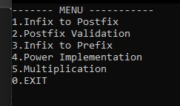

**Output Screenshots:**

1. 1.Infix To Postfix

1. Postfix Evaluation

1. Infix to prefix

1. Power Implementation

1. Multiplication

